MIDDLE CLASS MATHEMATICAL CONCEPTS TERM I 2026

LESSON NOTES FOR MATHEMATICAL CONCEPTS FOR MIDDLE
LEARNING AREA 4,
TERM ONE .
Developing and using mathematical concepts in my day to day experience
Surveying and distinguishing the attributes of objects I can count things and numbers 1-20
WEEK 1
Week 1-4
Suggested developmental activities
- Singing a song about number
“one two back my shoes Three four shirt the door”
- counting numbers 1-20 (by rote or one by one)
- showing how things are the same or different
- Identifying relationships among objects e.g ball with feet, cow with animals (one to one correspondence).
- Arranging objects according to the numbers
- Playing number games.
- Matching pictures to number symbols.
- Counting, reading and writing numbers.
- Matching sets of things, I know.
- Drawing for the number.
One Two Three Four Five Six Seven Eight Nine Ten

Activity
Write numbers from 1-10
1 2 3 4 5 6 7 8 9 10

Count the objects and write the numb | er
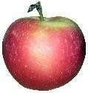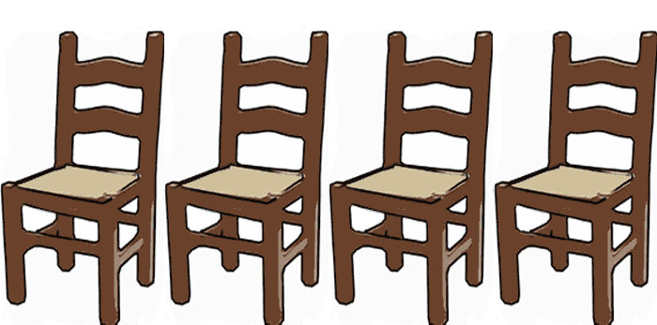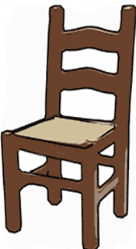

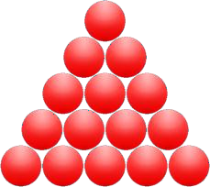Match the same sets

Write in words

1

6

Draw balls for the number

=5 =7 =6

Week 5-10
I can identify relationship, and differences between different objects and shapes.
Suggested developmental activities
- Singing a song about shapes e.g
“We know our shapes
I know my shapes I know a circle
I know a triangle”.
- Pairing of things.
- Naming objects of different shapes.
- Matching to find similarities and differences.
- Drawing and modeling shapes and objects.
- Sorting objects according to shapes, sizes and types.
- Cutting and pasting to form shapes.
Our shapes
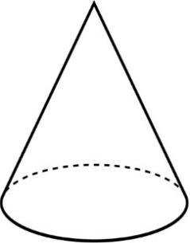

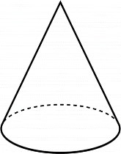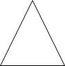Activity
1. Name the shapes
Circle |  | Rectangle | Star | Triangle


Match shapes to their names.
Triangle

Cone

Star

triangle

Note: Zig zag is a line or pattern not a shape. Comparing things according to different attributes I can show relations among things in serial order Suggested developmental activities
  - Comparing which one is
  - Bigger/smaller
  - Heavier/lighter
  - Rougher /smoother
  - Louder/softer
  - Longer/shorter
  - Taller/shorter
  - Wider/narrower.

Activity
Which one is shorter A B

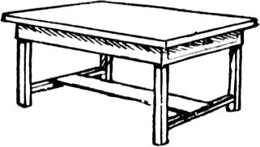Name the big, bigger and the biggest.
biggest | bigger | big
biggest | bigger | big

 |  | Circle the bigger
 |  |  |  |  | 
 |  |  | 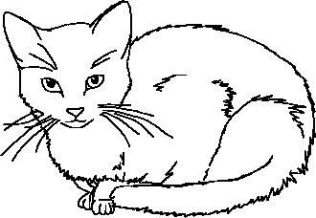 |  | 